Alpha-Beta Pruning Algorithm for Gaming
Aim
To implement the Alpha-Beta Pruning algorithm in Python to find the optimal move in a two-player game by eliminating unnecessary branches of the game tree.
Objective
- To understand the Minimax game-playing strategy.
- To implement Alpha-Beta pruning.
- To reduce the number of nodes evaluated during game search.
- To determine the optimal game value.
Algorithm
- Start with the root node and initialize alpha = -∞ and beta = +∞.
- If the current node is a leaf node, return its utility value.
- For a MAX node, select the maximum value from its children.
- Update alpha with the maximum value found.
- For a MIN node, select the minimum value from its children.
- Update beta with the minimum value found.
- If beta <= alpha, prune the remaining branches.
- Return the optimal value.
FLOW CHART:
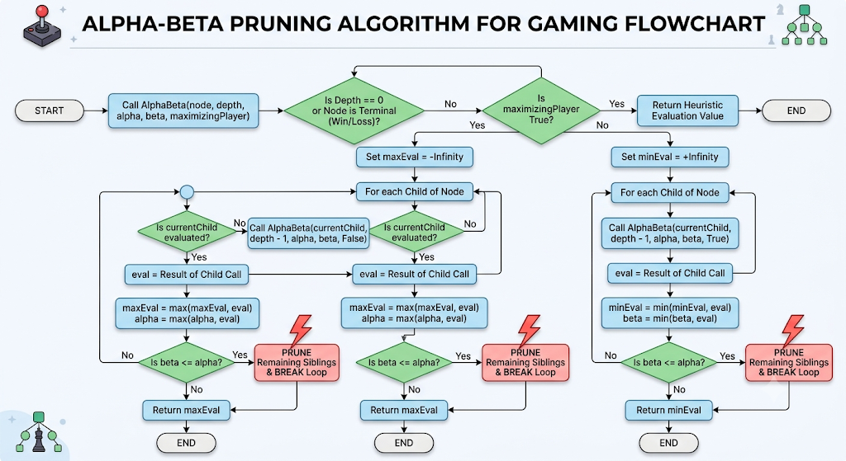
Python Code
def alpha_beta(depth, node, maximizing, values, alpha, beta):

# Leaf node
if depth == 3:
return values[node]

if maximizing:
best = float('-inf')

for i in range(2):
value = alpha_beta(
depth + 1,
node * 2 + i,
False,
values,
alpha,
beta
)

best = max(best, value)
alpha = max(alpha, best)

# Beta pruning
if beta <= alpha:
break

return best

else:
best = float('inf')

for i in range(2):
value = alpha_beta(
depth + 1,
node * 2 + i,
True,
values,
alpha,
beta
)

best = min(best, value)
beta = min(beta, best)

# Alpha pruning
if beta <= alpha:
break

return best

# Game tree leaf values
values = [3, 5, 6, 9, 1, 2, 0, -1]

result = alpha_beta(
0, 0, True,
values,
float('-inf'),
float('inf')
)

print("Optimal Game Value:", result)
OUTPUT:
Result
Optimal Game Value: 5

